

DEPARTMENT OF BASIC SCIENCE AND HUMANITIES(BSH)

INSTITUTE OF ENGINEERING AND MANAGEMENT, KOLKATA

**“STUDENT MANAGEMENT SYSTEM”**

**Submitted by:-**

**Name of the Student:** Avhishek Nandi

**Enrolment Number:** 12022002016039

**Registration Number:** 221040110395

**Section:** D

**Class Roll Number:** 13

**Stream:** Computer Science Engineering (AI/ML)

**Subject:** Programming for Problem Solving

**Subject Code:** ESC-103 (Pr)

Under the supervision of:**Prof. Swarnendu Ghosh**

**Academic Year: 2022-26**

(PROJECT REPORT SUBMITTED IN FULFILLMENT OF THE REQUIREMENTS FOR THE SECOND SEMESTER)



**CERTIFICATE OF RECOMMENDATION**

We hereby recommend that the project prepared under our supervision by **Avhishek Nandi**, entitled **“Student Management System”** be accepted in fulfilment of the requirements for the degree of fulfilment of the second semester.

|  |  |
| --- | --- |
| _____________________________ | _____________________________ |
| Head of the Department | Project Supervisor |
| IEM, Kolkata | Basic Science and Humanities |

# Introduction:

This project is assigned to me for developing a Student Management System with the help of basic C programming language.

The basic aim of the project is to create a Student Management System where we need to store various information about the student data including their name, roll numbers , marks and grades and manage them.

# Variable Description:

The different variables used in this project are listed under:-

1. int- To store integer datatypes.
2. char- To store character datatypes.
3. Array- To store the files altogether
4. float- to store floating(decimal containing numbers) datatypes.

# Function Description:

The different functions (structures) used in this project are listed under:-

* struct Student – stores the information of the students listed.
* char calculate_grade – returns the grade the student got according to their marks.

# Programs:

*project.c(name of the code file)*

#include <stdio.h>

#include <stdlib.h>

// Define a struct for student data

struct Student {

    char name[50];

    int roll_number;

    float marks;

    char grade;

};

// Function to calculate grade based on marks

char calculate_grade(float marks) {

    if (marks >= 90) {

        return 'A';

    } else if (marks >= 80) {

        return 'B';

    } else if (marks >= 70) {

        return 'C';

    } else if (marks >= 60) {

        return 'D';

    } else {

        return 'F';

    }

}

int main() {

    // Declare variables

    int num_students;

    struct Student *students;

    // Prompt the user to enter the number of students

    printf("Enter the number of students: ");

    scanf("%d", &num_students);

    // Allocate memory for the students array

    students = (struct Student*) malloc(num_students * sizeof(struct Student));

    // Loop through each student and get their data

    for (int i = 0; i < num_students; i++) {

        printf("Enter the name of student %d: ", i+1);

        scanf("%s", students[i].name);

        printf("Enter the roll number of student %d: ", i+1);

        scanf("%d", &students[i].roll_number);

        printf("Enter the marks of student %d: ", i+1);

        scanf("%f", &students[i].marks);

        // Calculate grade based on marks

        students[i].grade = calculate_grade(students[i].marks);

    }

    // Print out the student data

    printf("\nStudent Data:\n");

    printf("------------------------------------------------\n");

    printf("| %-20s | %-10s | %-10s |\n", "Name", "Roll No.", "Grade");

    printf("------------------------------------------------\n");

    for (int i = 0; i < num_students; i++) {

        printf("| %-20s | %-10d | %-10c |\n", students[i].name, students[i].roll_number, students[i].grade);

    }

    printf("------------------------------------------------\n");

    // Free memory allocated for the students array

    free(students);

    return 0;

}

# Outputs:

Sample outputs (screenshots) to demonstrate the functionalities in programs are listed below.

* First, we take input of the number of students in the class. (We are taking a small sample space)



* Enter the names of the student, their roll number and their marks one by one. Then we display the sheet with grades.

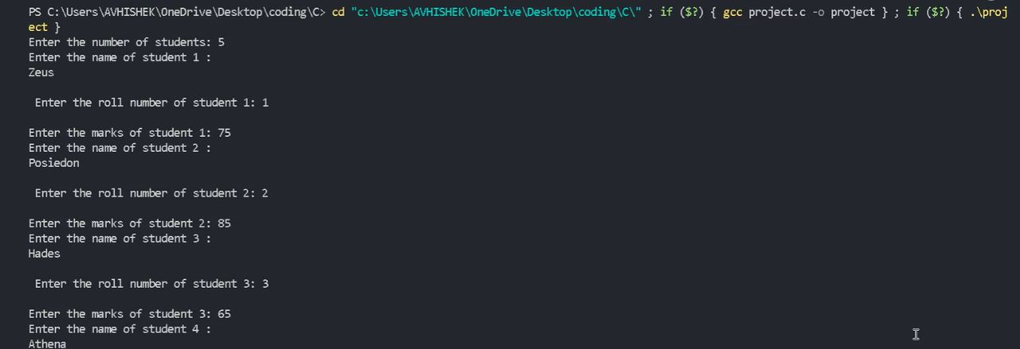

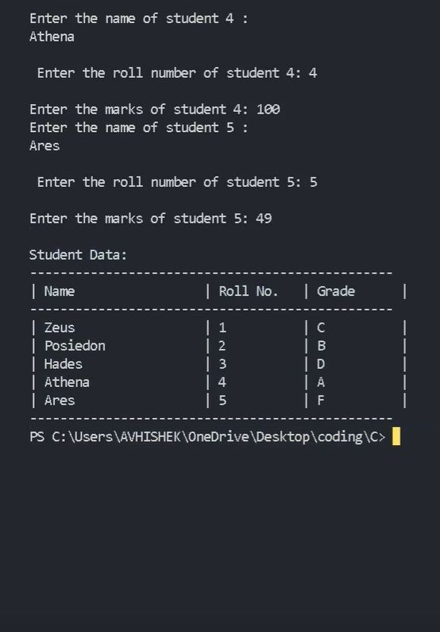

**--------------X---------X-------------**

**THANK YOU !**